Paper Title (Style: A – Paper Title)
First Author, Second Author
First Affiliation (Style: A – Affiliations)
Third Author
Second Affiliation (Style: A – Affiliations)
Abstract
Please use UK or US English when preparing your manuscript and be consistent. Include a short, 200–300-word Abstract using the (Style: A-Text.) Please don’t include abbreviations and references in the Title and the Abstract.

Introduction (Style: A - Heading 1)
Text in the Introduction (Style: A-Text.)

Example heading (Style: A - Heading 1)
This is a bulleted list,
- First level (Style: A - Bulleted list),
  - this is a second level (Style: Bulleted list (A - Second level)).
This is a numbered list,
- please use this format (Style: A – Numbered list).

Figures, Tables Units and Equations (Style: A - Heading 1)
Try to ensure that every heading is followed by text.

Figures (Style: Heading 2)
Figure 1a) and b) illustrate the proposed way to add titles to figures (Style: A – Figure Title, and Style: A – Figure). Use the text-wrap option “In line with text” for your figures. Use the “Cross-reference” feature to reference to your figures (e.g. Figure 1, caption label: Figure). Cross-references are to be placed manually in-text to reference each figure before their occurrence.
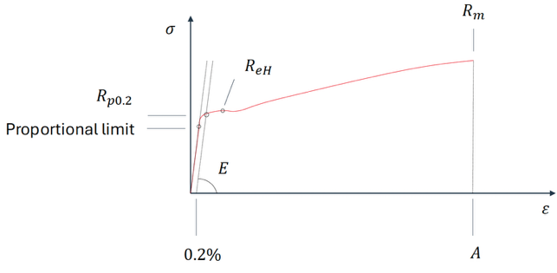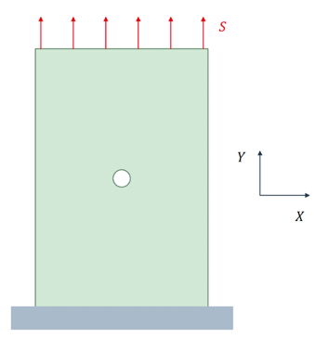
a)
b)
Figure 2: a) True stress-strain curve for a structural steel, b) plate with a hole

Tables
Submit tables as modifiable text and use the “Cross-reference” feature to reference your tables (e.g. Table 1, caption label: Table Title). The title of the table should have the Style: A – Table title. Table 1 provides an example.
Table 1: Currently running NAFEMS projects
Project Name | Project Lead | Estimated Cost ($) | Completion Date
Hyperloop Extension | Jason Martell | 2,500,000,000 | December 2028
Quantum Processor Design | Rachel A. Tao | 1,000,000,000 | April 2029

Units and abbreviations
Symbols for physical quantities should be italicized (such as T, σ, etc.). Conversely, unit symbols comprised of letters should be in regular text (for instance, ms⁻¹, K, min, mm, etc.). Additional information can be found in the Guide for the Use of the International System of Units (SI) [5]. Abbreviations should be spelled out completely when they first appear in the text, followed by the abbreviation in brackets, like Finite Element Analysis (FEA).

Equations
Use the built-in equation editor to input your equations. Equations should have the Style: A – Equation, the equation numbering should have the Style: A – Equation number.
For example, the Crossland equivalent stress ($σ_{Cr}$) is calculated as
$σ_{Cr}=\sqrt{J_{2,a}}+α_{Cr}σ_{h,max}$ , | 1.
where $J_{2,a}$ is the amplitude of the second invariant of the deviatoric stress tensor (MPa), $α_{Cr}$ is a material parameter and $σ_{h,max}$ is the maximum of the hydrostatic stress.

Conclusions
Text in the Conclusions.

Acknowledgement
An optional section.

Nomenclature
The Nomenclature section is optional; notations and symbols can be also introduced at their occurrence in text.
g | Gravitational acceleration (m/s²)
m | Mass (kg)

References
Use the IEEE reference style. Ensure all references mentioned in the text appear in the reference list and vice versa. List references numerically in the order they are cited in the text. (Style for the References: “A – Reference list”). The list of references is a numbered list; a reference in text includes adding a “Cross-reference” to the respective “Numbered item”.
- J. K. Author, “Title of chapter in the book” in Title of His Published Book, xth ed. City of Publisher, (only U.S. State), Country: Abbrev. of Publisher, year, ch. x, sec. x, pp. xxx–xxx.
- J. K. Author, “Title of paper” presented at the Abbreviated Name of Conf., City of Conf., Abbrev. State, Country, Month and day(s), year, Paper number.
- “Page Title.” Website Title. Date Accessed. [Online]. Available: Web Address. [Accessed: Date].
- Title of Standard, Standard number, Corporate author, location, date.
- National Institute of Standards and Technology, “Guide for the Use of the International System of Units (SI)”, NIST Special Publication 811, 2008. [Online]. Available: https://physics.nist.gov/cuu/pdf/sp811.pdf. [Accessed: 10.11.2025].

